**Infix To Postfix Conversion Using Stack**

One of the applications of Stack is in the conversion of

arithmetic expressions in high-level programming

languages into machine readable form. As our computer

system can only understand and work on a binary

language, it assumes that an arithmetic operation can take

place in two operands only e.g., **A+B, C*D,D/A** etc. But in

our usual form an arithmetic expression may consist of

more than one operator and two operands e.g.

**(A+B)*C(D/(J+D))**.

These complex arithmetic operations can be converted into

polish notation using stacks which then can be executed in

two operands and an operator form.

**Infix Expression**

It follows the scheme of **<operand><operator><operand>**

i.e. an <operator> is preceded and succeeded by an

<operand>. Such an expression is termed infix expression.

E.g., **A+B**

**Postfix Expression**

It follows the scheme of **<operand><operand><operator>**

i.e. an <operator> is succeeded by both the <operand>.

E.g., **AB+**

**Advantage of Postfix Expression over Infix Expression**

An infix expression is difficult for the machine to know and keep track of precedence of operators. On the other hand, a postfix expression itself determines the precedence of operators (as the placement of operators in a postfix expression depends upon its precedence).Therefore, for the

machine it is easier to carry out a postfix expression than an infix expression.

**Algorithm to convert Infix To Postfix**

Let, X is an arithmetic expression written in infix notation.

This algorithm finds the equivalent postfix expression Y.

1. Push “(“onto Stack, and add “)”to the end of X.

2.Scan X from left to right and repeat Step 3 to 6 for each

element of X until the Stack is empty.

3. If an operand is encountered, add it to Y.

4. If a left parenthesis is encountered, push it onto Stack.

5. If an operator is encountered ,then:

1. Repeatedly pop from Stack and add to Y each

operator (on the top of Stack) which has the same

precedence as or higher precedence than operator.

2. Add operator to Stack.

[End of If]

6. If a right parenthesis is encountered ,then:

1. Repeatedly pop from Stack and add to Y each

operator (on the top of Stack) until a left

parenthesis is encountered.

2.Remove the left Parenthesis.

[End of If]

[End of If]

7. END.

**Let’s take an example to better understand the algorithm**

Infix Expression: **A+ (B*C-(D/E^F)*G)*H**, where **^** is

an exponential operator.

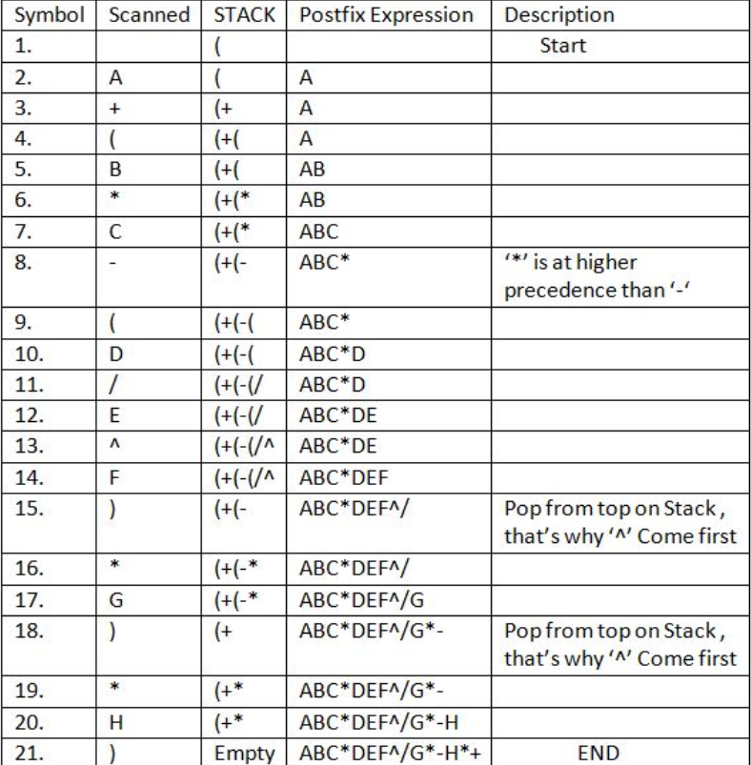

**Resultant Postfix Expression: ABC*DEF^/G*-H*+**

[Program](in_to_post.c)